DMET 1001 – Image Processing
Assignment 3 — Report
Multi-threshold Image Segmentation using the Gray Wolf Optimizer (GWO) + Otsu Objective
Spring 2026 — German University in Cairo, Faculty of Media Engineering and Technology

1. Introduction
Image segmentation by multi-level thresholding partitions a grayscale image into k+1 classes using k threshold values. The assignment explores two open questions: (a) how many thresholds k to use, and (b) which exact threshold values are optimal. We maximise the Otsu between-class variance using the Gray Wolf Optimizer (GWO), sweeping k = 2 … 6 on three images and identifying the elbow of the fitness curve to choose the optimal k.

2. Method

2.1 Otsu Between-Class Variance (Fitness Function)
Given sorted thresholds t₁ < t₂ < … < tₖ, the histogram is split into k+1 classes. The fitness is the weighted between-class variance: σ²_B = Σ ωᵢ(μᵢ − μ_T)², where ωᵢ is the class probability, μᵢ the class mean, and μ_T the global mean. Maximising σ²_B yields the most separated, cohesive classes.

2.2 Gray Wolf Optimizer (GWO)
GWO simulates grey wolf pack hierarchy: 25 candidate threshold vectors evolve over 60 iterations. The three best solutions (α, β, δ) guide the rest. A linearly decreasing parameter a ∈ [2→0] controls the balance between exploration and exploitation. GWO is well-suited here because the search space (integers in [1, 255]^k) is small and the landscape is non-convex.

2.3 Output Visualisations
- Mean-intensity colouring (conventional): each segment is filled with the mean grey value of its pixels.
- Random RGB colouring: each segment is assigned a distinct random colour for easy visual inspection of segment boundaries.

3. Image 1 — Fruits & Vegetables
A grayscale photograph of a food arrangement featuring asparagus, fruits, vegetables, a glass of milk, cheese, eggs, and bread. The image has a wide dynamic range: dark background and dark vegetables, mid-grey produce, light dairy items, and near-white highlights.

3.1 Original Image
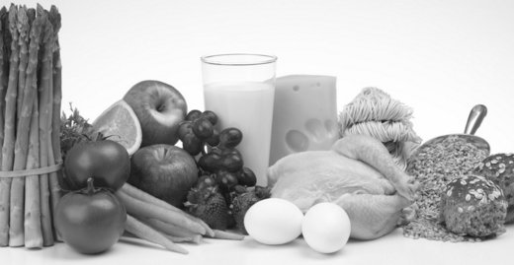
Figure 1.1 — Image 1 original grayscale image.

3.2 Segmentation for k = 2 to 6
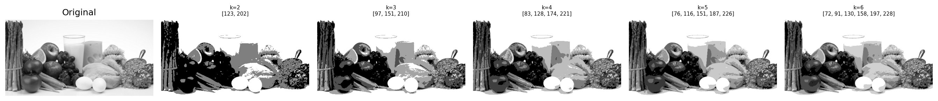
Figure 1.2 — Segmentation results for k = 2, 3, 4, 5, 6. Thresholds found by GWO shown above each panel.

3.3 Otsu Variance vs k
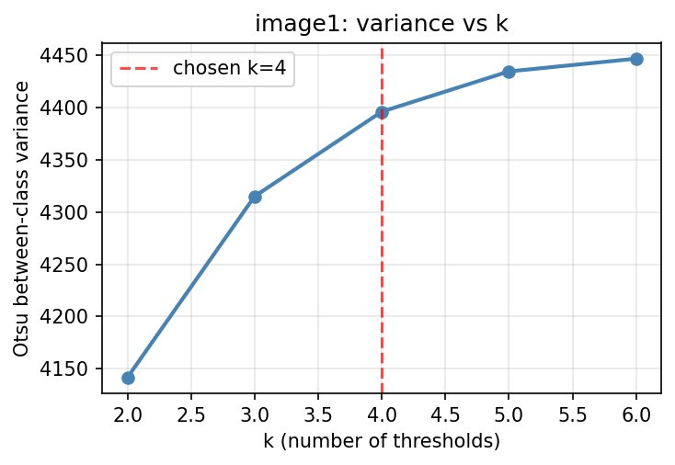
Figure 1.3 — Otsu between-class variance as a function of k. The red dashed line marks the chosen elbow at k = 4.

3.4 Best Result (k = 4, thresholds = [82, 120, 168, 221])
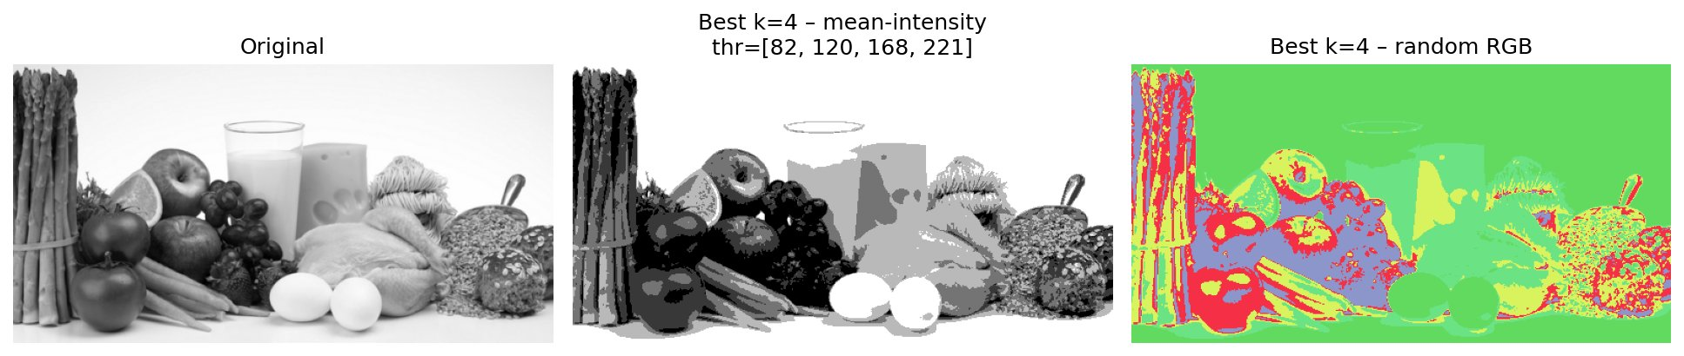
Figure 1.4 — Left: original. Centre: mean-intensity segmentation (k=4, thr=[82,120,168,221]). Right: random RGB colouring.

3.5 Quantitative Summary
k | Thresholds found by GWO | Between-class variance
k=2 | [123, 202] | 4,143
k=3 | [97, 151, 210] | 4,314
k=4 ★ | [82, 120, 168, 221] | 4,395
k=5 | [76, 116, 151, 187, 226] | 4,433
k=6 | [72, 91, 130, 158, 197, 228] | 4,448

3.6 Discussion
- k=2: Only three intensity classes — dark background merged with dark vegetables, bright items grouped together. Many visually distinct items share the same segment.
- k=3: Three thresholds begin to separate dark, mid, and light groups, but highlights (milk, eggs) are still blended with mid-grey cheese.
- k=4 (chosen ★): Thresholds [82, 120, 168, 221] isolate four meaningful bands — dark background/vegetables, mid-dark produce, light dairy items, and bright highlights (eggs, milk glass). The elbow of the variance curve confirms this is the optimal point.
- k=5, k=6: Further splits fragment individual items (e.g. a single piece of fruit split into two intensity bands). Marginal variance gain drops below 25% of the first jump — over-segmentation with no visual benefit.

4. Image 2 — Brain MRI Scan
An axial brain MRI slice in grayscale. The image contains a black background, dark skull boundary, grey brain matter with internal structure, and two bright white lesion/signal spots. Accurate segmentation of this image has direct medical relevance.

4.1 Original Image
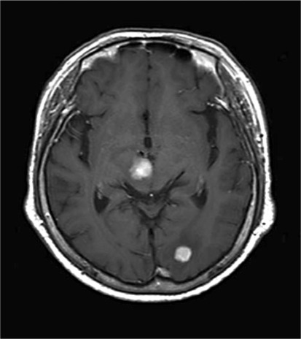
Figure 2.1 — Image 2 original grayscale MRI scan.

4.2 Segmentation for k = 2 to 6
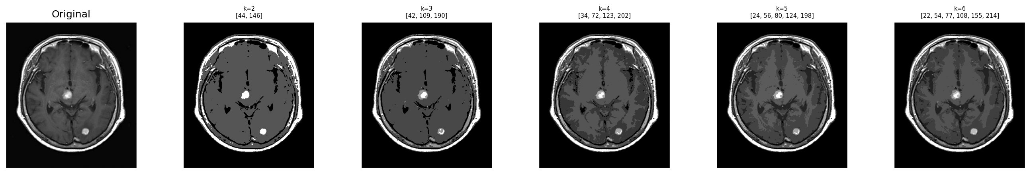
Figure 2.2 — Segmentation results for k = 2, 3, 4, 5, 6 on the MRI image.

4.3 Otsu Variance vs k
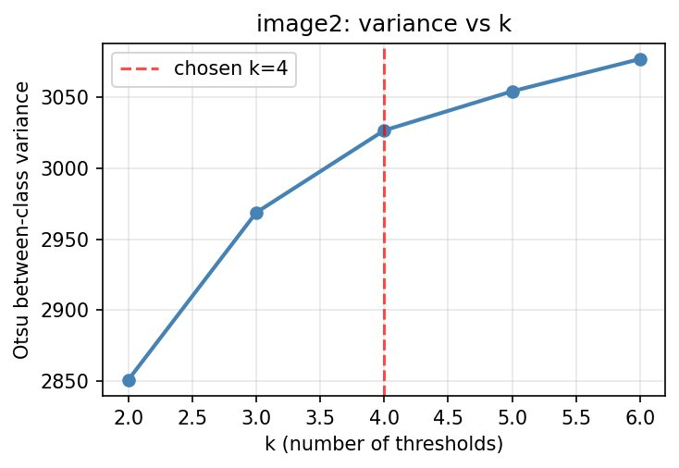
Figure 2.3 — Variance vs k for Image 2. Elbow at k = 4 chosen.

4.4 Best Result (k = 4, thresholds = [32, 73, 122, 191])
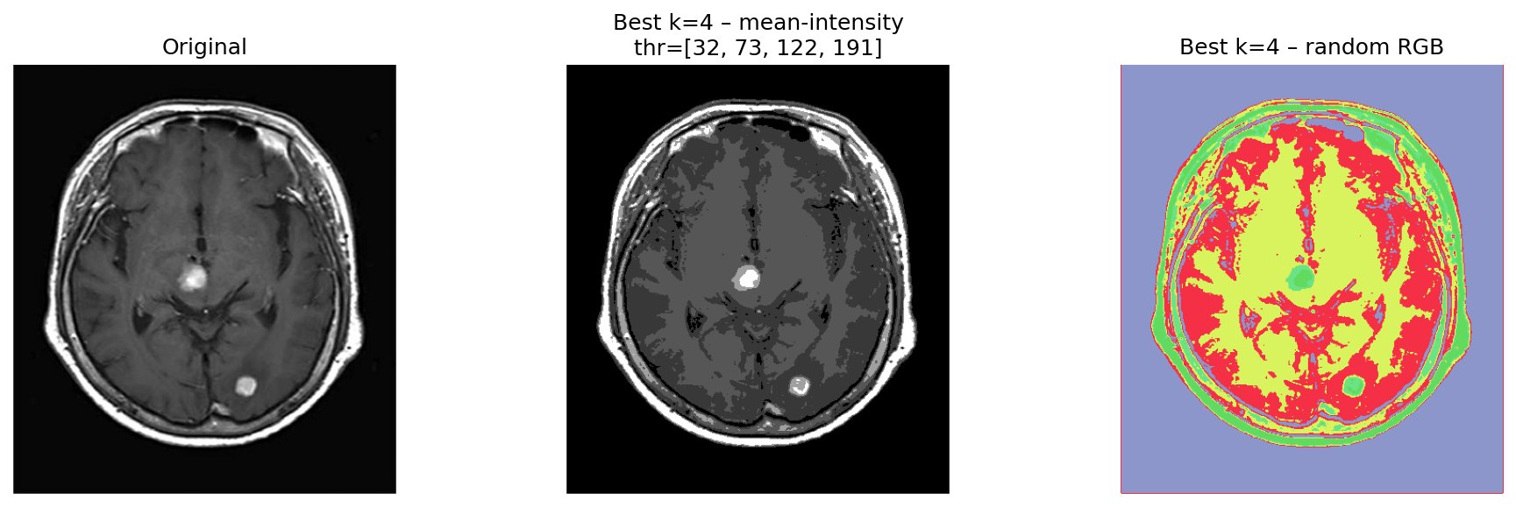
Figure 2.4 — Left: original MRI. Centre: mean-intensity segmentation (k=4, thr=[32,73,122,191]). Right: random RGB colouring.

4.5 Quantitative Summary
k | Thresholds found by GWO | Between-class variance
k=2 | [44, 146] | 2,851
k=3 | [42, 109, 190] | 2,967
k=4 ★ | [34, 73, 122, 202] | 3,025
k=5 | [24, 56, 80, 124, 198] | 3,053
k=6 | [22, 54, 77, 108, 155, 214] | 3,074

4.6 Discussion
- k=2: Background and skull boundary are merged; all brain matter and both lesions collapse into one bright class. Clinically useless.
- k=3: Three thresholds separate background, brain matter, and a bright class — but the two lesions and the skull boundary are still merged.
- k=4 (chosen ★): Thresholds [32, 73, 122, 191] cleanly isolate: (1) black background, (2) dark skull boundary, (3) grey brain matter, and (4) bright lesion spots. Each segment corresponds to a clinically meaningful anatomical region.
- k=5, k=6: Grey matter is subdivided into two near-identical bands that do not correspond to distinct anatomical structures. The variance gain is negligible — over-segmentation.

5. Image 3 — Aerial Satellite Image
A high-resolution aerial photograph of a dense urban area (Paris-style Haussmann grid) converted to grayscale. The image contains dark road networks, building rooftops of varying brightness, courtyards, and small bright features (vehicles, skylights). This is the most complex image of the three, with a near-uniform intensity histogram.

5.1 Original Image
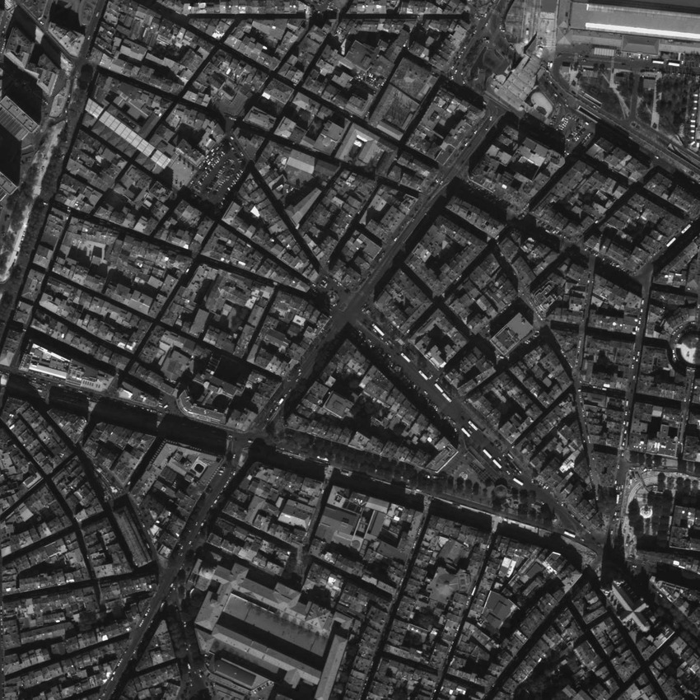
Figure 3.1 — Image 3 original grayscale aerial image.

5.2 Segmentation for k = 2 to 6
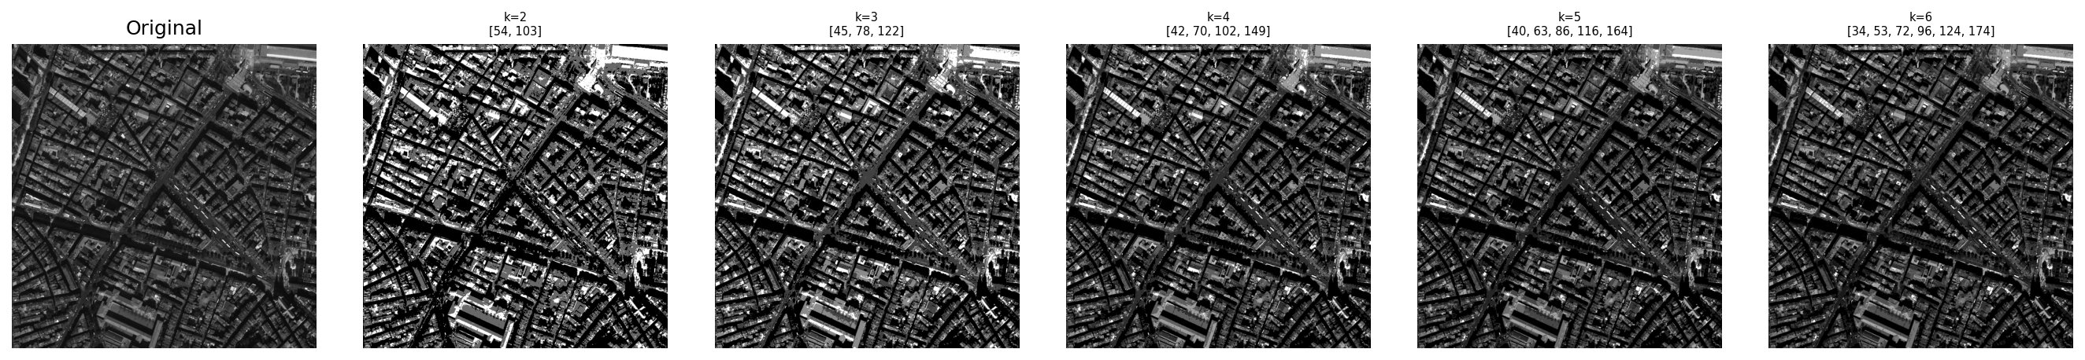
Figure 3.2 — Segmentation results for k = 2, 3, 4, 5, 6 on the aerial image.

5.3 Otsu Variance vs k
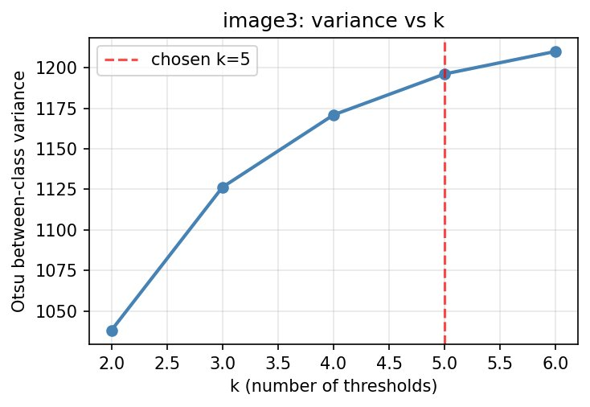
Figure 3.3 — Variance vs k for Image 3. Elbow at k = 5 chosen.

5.4 Best Result (k = 5, thresholds = [40, 63, 86, 116, 163])
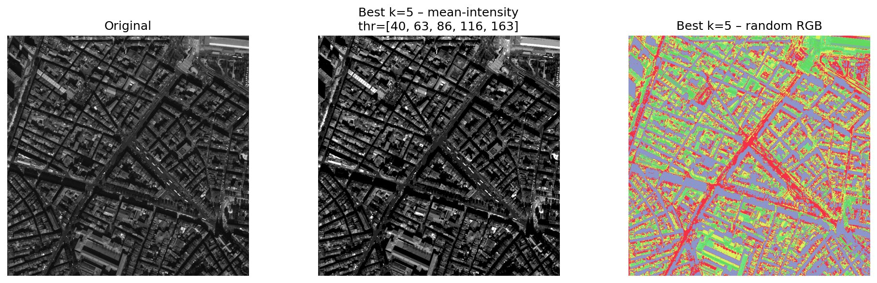
Figure 3.4 — Left: original aerial. Centre: mean-intensity segmentation (k=5, thr=[40,63,86,116,163]). Right: random RGB colouring clearly delineating roads and rooftops.

5.5 Quantitative Summary
k | Thresholds found by GWO | Between-class variance
k=2 | [54, 103] | 1,038
k=3 | [45, 78, 122] | 1,126
k=4 | [42, 70, 102, 149] | 1,171
k=5 ★ | [40, 63, 86, 116, 163] | 1,196
k=6 | [34, 53, 72, 96, 124, 174] | 1,210

5.6 Discussion
- k=2: Only roads vs everything else — all rooftops, courtyards, and open areas are a single class. No structural detail is captured.
- k=3: Adds a mid-grey class for pavements and open courtyards, but rooftop variation is collapsed into one bright class.
- k=4: Separates dark roads, mid-grey courtyards, lighter rooftops and bright highlights — reasonable but the complex rooftop variation is still under-segmented.
- k=5 (chosen ★): Thresholds [40, 63, 86, 116, 163] produce five classes: very dark roads/shadows, dark building edges, mid-grey courtyards, light rooftops, and bright rooftop features. The diagonal road network is clearly delineated in the RGB image. Variance elbow confirms this choice.
- k=6: Adds a sixth class that splits an already-coherent rooftop band — marginal gain is small and visual output shows noise sensitivity rather than new structure.

6. How Is the Optimal Number of Thresholds Decided?
The Otsu between-class variance is monotonically non-decreasing in k — adding a threshold can only improve or maintain the objective value. Maximising variance alone always recommends the largest k, which is not useful. We therefore combine three complementary criteria:
- Elbow rule on the variance curve: We pick the smallest k for which the next marginal gain drops below 25% of the first jump (k=2→3). After this point, additional thresholds fragment already-cohesive regions into artificial sub-classes.
- Visual cohesiveness: A useful segment corresponds to a single perceptually homogeneous region. If raising k splits one such region into two visually similar parts, k is already too large.
- Histogram modes: The number of peaks in the intensity histogram hints at the natural number of classes. The optimal k is typically equal to (number of dominant modes − 1).

Applying these three criteria to our images:
- Image 1 (Fruits): k = 4, thresholds [82, 120, 168, 221] — isolates dark background, mid-dark produce, light dairy, and bright highlights.
- Image 2 (Brain MRI): k = 4, thresholds [32, 73, 122, 191] — separates background, skull, grey brain matter, and bright lesion spots.
- Image 3 (Aerial): k = 5, thresholds [40, 63, 86, 116, 163] — delineates roads, building edges, courtyards, rooftops, and bright features.

7. Conclusion
The Gray Wolf Optimizer reliably converges to high-quality Otsu threshold sets on all three images within 60 iterations and a pack size of 25. The optimal number of thresholds is determined objectively by the elbow of the variance curve, confirmed by visual inspection. Increasing k beyond the elbow produces over-segmented outputs where perceptually coherent regions are split into artificial sub-classes with negligible fitness improvement. The chosen (k, thresholds) tuples reported above represent the best balance between segmentation quality and visual cohesiveness for each image type.

